RSI-Based Signal Merge and Plot (Final Version)
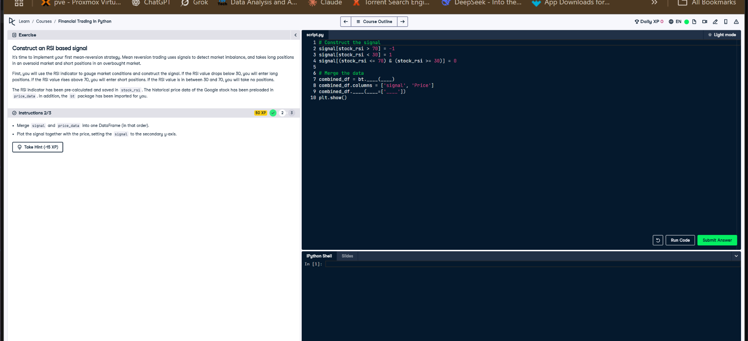
Figure: Exercise for merging RSI signal and plotting with secondary axis.

Python Code
# Construct the signal
signal[stock_rsi > 70] = -1
signal[stock_rsi < 30] = 1
signal[(stock_rsi <= 70) & (stock_rsi >= 30)] = 0
# Merge the data
combined_df = bt.merge(signal, price_data)
combined_df.columns = ['signal', 'Price']
# Plot with secondary y-axis for signal
combined_df.plot(secondary_y=['signal'])
plt.show()

Explanation
This code constructs an RSI-based signal, merges it with stock price data, and plots the result. A sell signal (-1) is set when RSI > 70, and a buy signal (1) is set when RSI < 30. `bt.merge()` combines both series into one DataFrame. The plot uses a secondary y-axis to clearly show the signal alongside the stock price.

AI-Generated Hint
Have you checked if you are merging the signal and price_data DataFrames correctly and setting the signal to the secondary y-axis in the plot?
# Example of merging two DataFrames
combined_df = bt.merge(signal, price_data)
# Example of plotting with a secondary y-axis
combined_df.plot(secondary_y=['signal'])
plt.show()

